# DSA theory guide
- Basic intro (what do you learn about)
- Key points
- Example
- Diagram
- Real life use case
#Linear data structure
- Arrays

🔹 Basic Introduction
An array is a basic data structure used to store multiple values of the same data type in a single variable. The elements in an array are stored in contiguous memory locations and each element can be accessed using its index. Arrays help organize data efficiently and are one of the first topics learned in Data Structures and Algorithms (DSA).

🔹 Key Points
- Stores elements of same data type
- Uses index-based access (starts from 0)
- Memory is contiguous
- Fixed size (in most languages like C, Java)
- Fast access time: O(1)
- Insertion and deletion can be slow

🔹 Example
int[] numbers = {10, 20, 30, 40};
System.out.println(numbers[2]); // Output: 30
Here, numbers[2] accesses the element at index 2.

🔹 Diagram
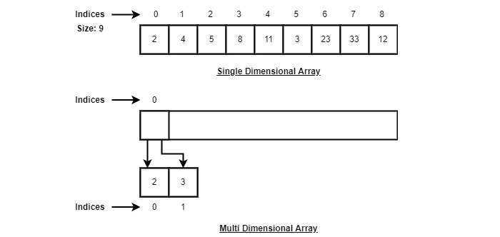

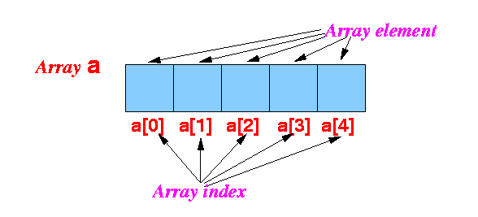

🔹 Real-Life Use Case
- Storing marks of students
- Managing daily temperatures of a week
- Holding prices of products in an e-commerce app
- Storing scores in a game leaderboard
Arrays are widely used because they are simple, fast, and easy to implement, making them a foundation for learning advanced data structures like stacks, queues, and matrices.

- String

🔹 Basic Introduction
A string is a data structure used to store a sequence of characters. Characters can include letters, numbers, symbols, and spaces. In most programming languages, strings are treated as arrays of characters, but with extra built-in functions that make text handling easier. Strings are very important in DSA because many real-world problems involve text processing.

🔹 Key Points
- Stores a sequence of characters
- Characters are accessed using index values
- Can be mutable or immutable (immutable in Java, Python)
- Common operations: length, comparison, substring, concatenation
- Used heavily in searching and pattern matching problems
- Takes more memory compared to single characters

🔹 Example
String name = "Vivek";
System.out.println(name.charAt(1)); // Output: i
Here, charAt(1) accesses the character at index 1.

🔹 Diagram
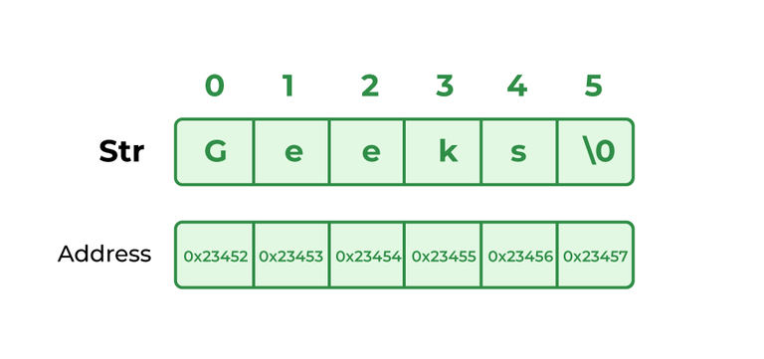

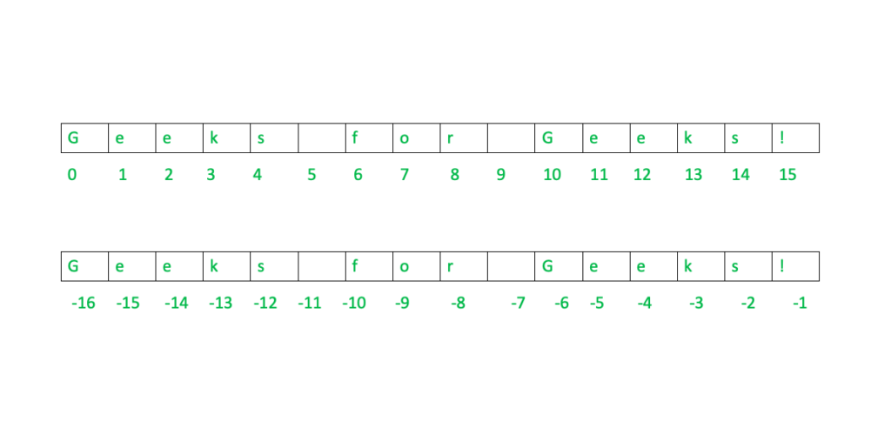

🔹 Real-Life Use Case
- Storing usernames and passwords
- Handling search queries in search engines
- Processing messages, emails, and documents
- Working with URLs and file paths
Strings are one of the most commonly used data structures because almost every application needs to handle text data efficiently.

3.stack

🔹 Basic Introduction
A stack is a linear data structure that follows the principle LIFO (Last In, First Out). This means the element added last is removed first. You can imagine a stack like a pile of books where you can only add or remove the top book. In DSA, stacks are used to manage data in a controlled order.

🔹 Key Points
- Follows LIFO principle
- Main operations: push, pop, peek
- Insertion and deletion happen only at the top
- Can be implemented using arrays or linked lists
- Used in recursion and expression evaluation
- Overflow and underflow are common stack conditions

🔹 Example
Stack<Integer> stack = new Stack<>();
stack.push(10);
stack.push(20);
stack.pop(); // Removes 20
Here, 20 is removed first because it was added last.

🔹 Diagram
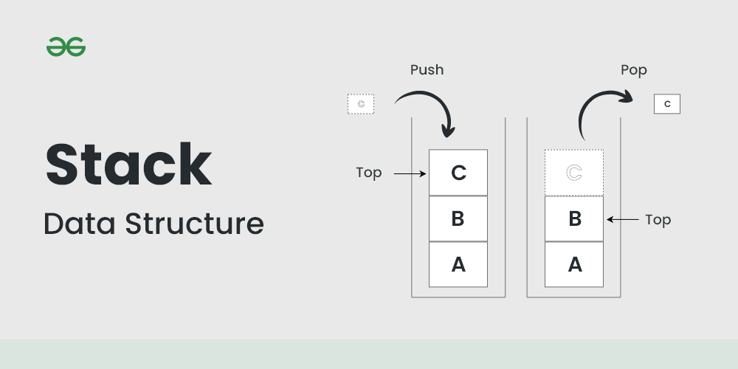
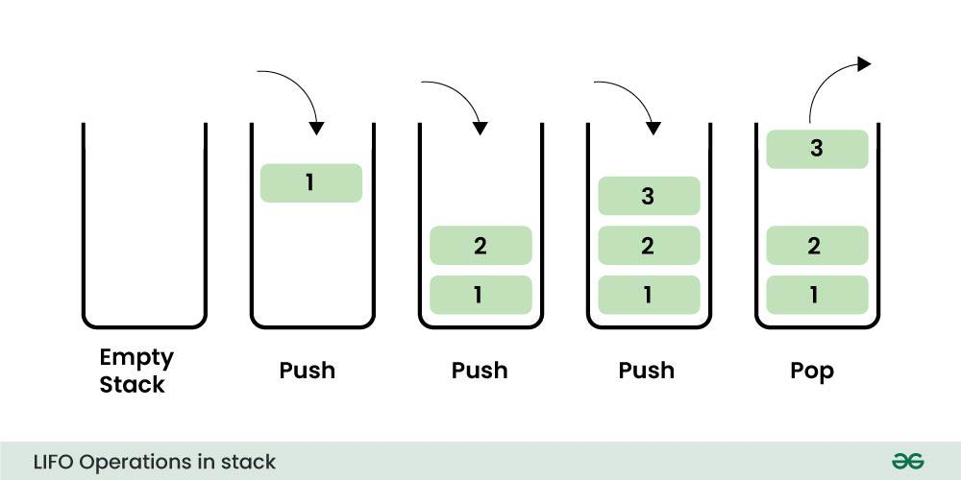
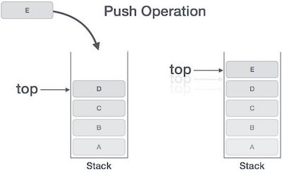

🔹 Real-Life Use Case
- Undo/Redo operations in text editors
- Function calls in programming (call stack)
- Back/Forward navigation in browsers
- Reversing a string or data sequence
Stacks are important in DSA because they help solve problems that require tracking previous states or operations in a simple and efficient way.

4.queue

🔹 Basic Introduction
A queue is a linear data structure that follows the principle FIFO (First In, First Out). This means the element that is added first is removed first. A real-world example of a queue is a line of people waiting for a ticket. In DSA, queues are used when data needs to be processed in the same order it arrives.

🔹 Key Points
- Follows FIFO principle
- Main operations: enqueue (insert), dequeue (remove)
- Insertion happens at the rear, deletion at the front
- Can be implemented using arrays or linked lists
- Types: simple queue, circular queue, priority queue, deque
- Used in scheduling and buffering systems

🔹 Example
Queue<Integer> queue = new LinkedList<>();
queue.add(10);
queue.add(20);
queue.poll(); // Removes 10
Here, 10 is removed first because it was inserted first.

🔹 Diagram
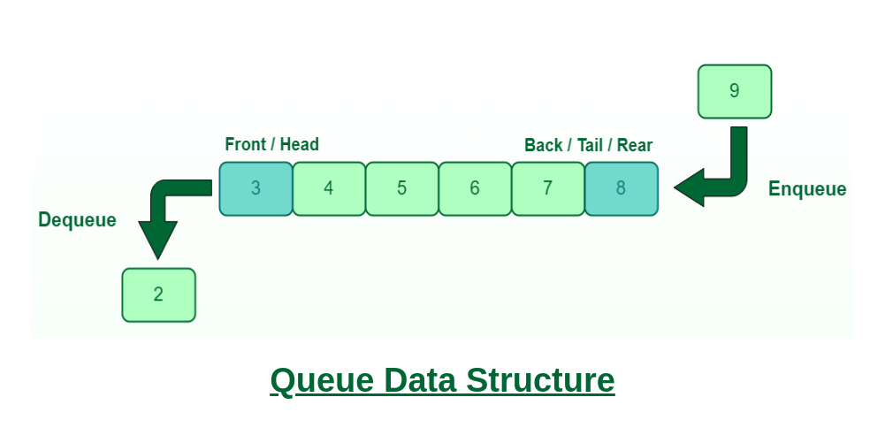
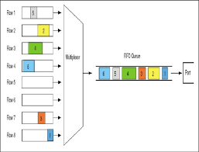
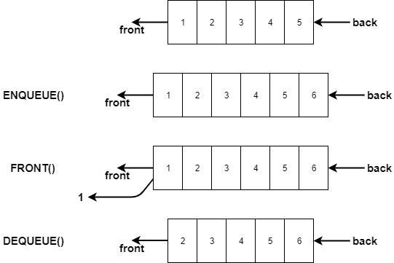

🔹 Real-Life Use Case
- Ticket booking systems
- CPU scheduling in operating systems
- Printer queue management
- Request handling in web servers
Queues are very useful in DSA for managing tasks, resources, and data in an organized and fair manner.

5. Linked List

🔹 Basic Introduction
A linked list is a linear data structure used to store a collection of elements called nodes. Each node contains two parts: data and a reference (link) to the next node in the sequence. Unlike arrays, linked lists do not store elements in contiguous memory locations, which makes insertion and deletion easier.

🔹 Key Points
- Each element is called a node
- Every node stores data + address of next node
- Memory is not contiguous
- Dynamic size (can grow or shrink easily)
- Slower access compared to arrays (O(n))
- Types: singly, doubly, and circular linked lists

🔹 Example
class Node {
int data;
Node next;
}

Node head = new Node();
head.data = 10;
head.next = null;
This example shows a single node of a linked list.

🔹 Diagram

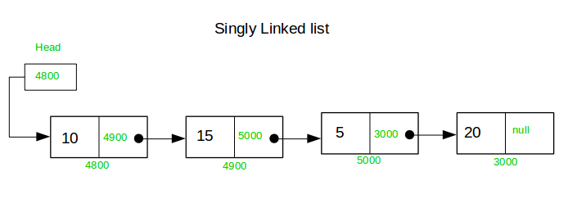
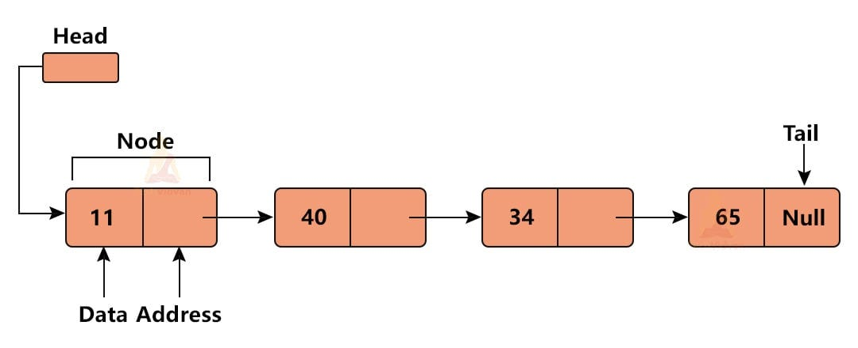

🔹 Real-Life Use Case
- Music playlist (next song pointer)
- Browser history navigation
- Dynamic memory allocation
- Implementation of stacks and queues
Linked lists are important in DSA because they provide flexibility in memory usage and form the base for many advanced data structures.

# non linear data structure
6.Trees

🔹 Basic Introduction
A tree is a non-linear data structure used to store data in a hierarchical form. It consists of nodes connected by edges, starting from a top node called the root. Each node can have multiple child nodes. Trees are widely used in DSA to represent relationships like parent–child structures.

🔹 Key Points
- Consists of nodes and edges
- Top node is called the root
- Every node can have child nodes
- No cycles are present in a tree
- Common terms: parent, child, sibling, leaf
- Types: binary tree, BST, AVL, heap, trie

🔹 Example
class Node {
int data;
Node left, right;
}

Node root = new Node();
root.data = 10;
root.left = null;
root.right = null;
This example shows a single root node of a tree.

🔹 Real-Life Use Case
- File system (folders and subfolders)
- Organization hierarchy
- HTML DOM structure
- Decision-making systems
Trees are very powerful in DSA because they help manage hierarchical data efficiently and are the foundation for fast searching and sorting techniques.

🔹 Diagram
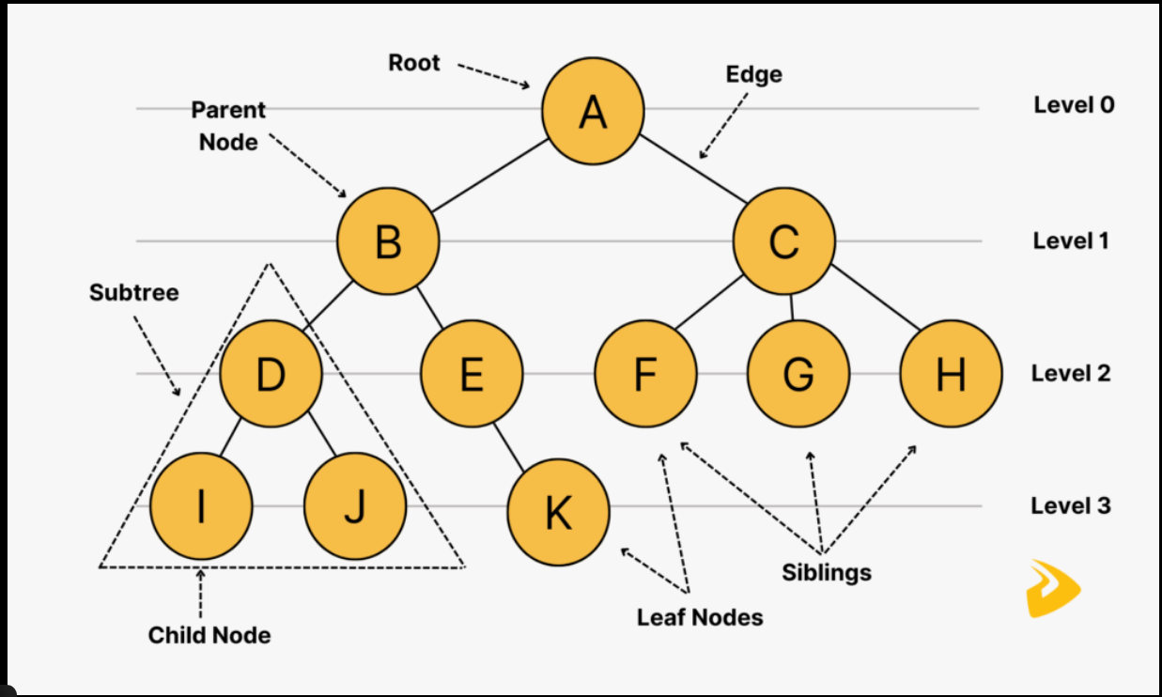
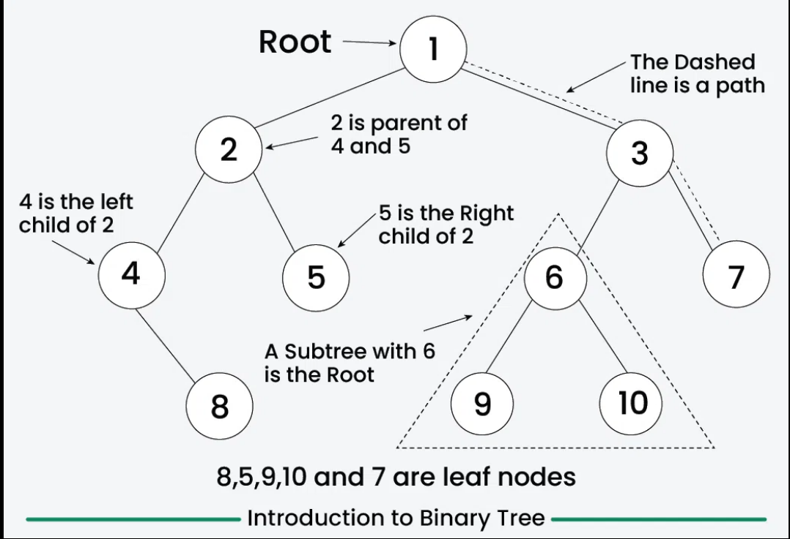

7.graphs

🔹 Basic Introduction
A graph is a non-linear data structure used to represent relationships between different entities. It consists of vertices (nodes) and edges (connections). Unlike trees, graphs can have cycles and multiple paths between nodes. Graphs are widely used in DSA to model real-world networks.

🔹 Key Points
- Consists of vertices (nodes) and edges
- Can be directed or undirected
- Can be weighted or unweighted
- May contain cycles
- Represented using adjacency matrix or adjacency list
- Used in traversal algorithms like BFS and DFS

🔹 Example
import java.util.*;

class Graph {
int V;
List<List<Integer>> adj;

Graph(int V) {
this.V = V;
adj = new ArrayList<>();
for (int i = 0; i < V; i++)
adj.add(new ArrayList<>());
}
}
This example shows the basic structure of a graph using an adjacency list.

🔹 Diagram
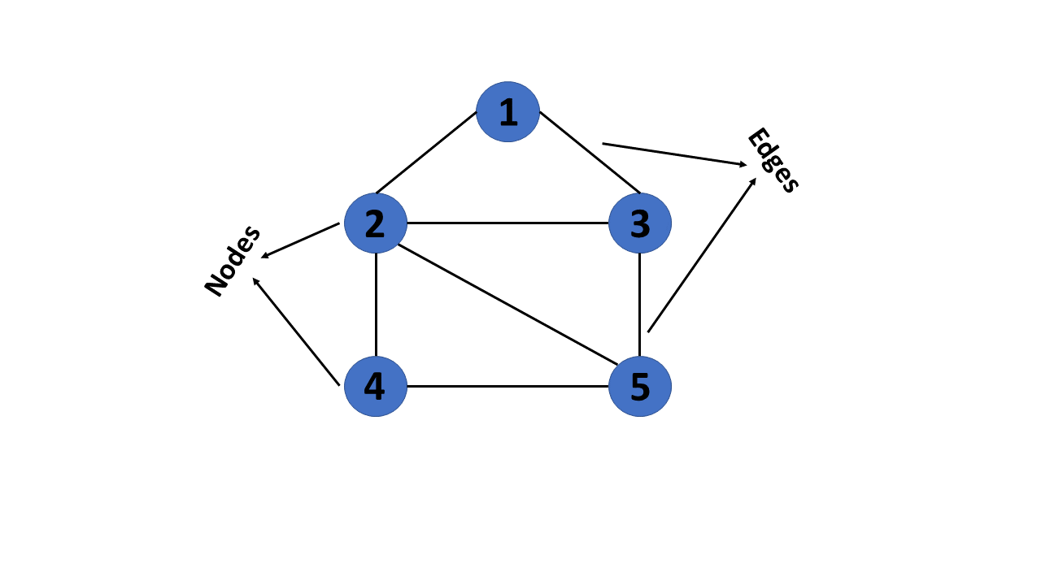
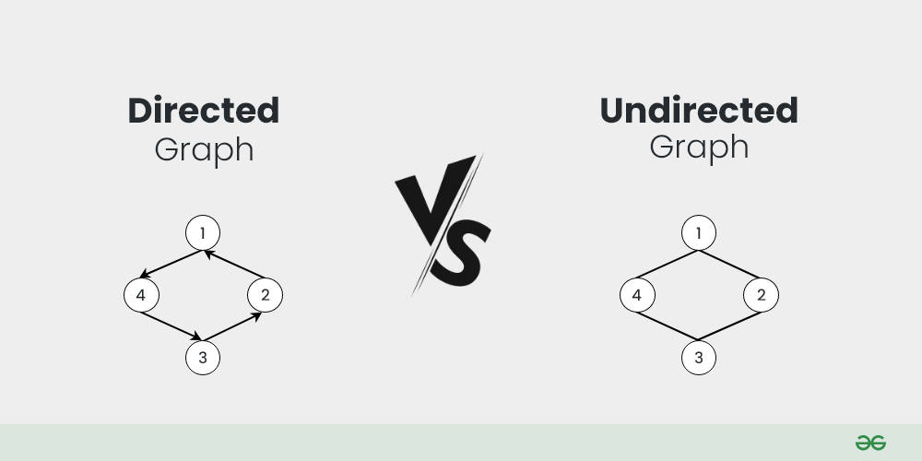
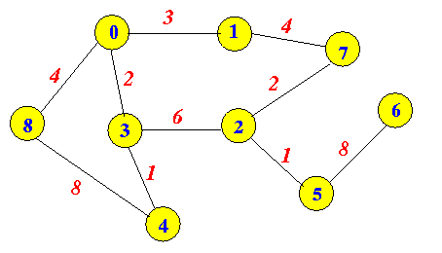

🔹 Real-Life Use Case
- Social networks (users and connections)
- Google Maps and route planning
- Computer networks
- Recommendation systems
Graphs are one of the most powerful data structures in DSA because they help solve complex relationship and pathfinding problems efficiently.

8.heap data structure

🔹 Basic Introduction
A heap is a special type of tree-based data structure that follows the heap property. It is usually implemented using a binary tree and is commonly used to manage data where quick access to the minimum or maximum element is required.
There are two main types of heaps:
- Max Heap – the parent node is always greater than or equal to its children
- Min Heap – the parent node is always smaller than or equal to its children

🔹 Key Points
- A heap is a complete binary tree
- Follows the heap property
- Two types: Min Heap and Max Heap
- Insert and delete operations take O(log n) time
- Accessing min/max element takes O(1) time
- Commonly implemented using arrays

🔹 Example
PriorityQueue<Integer> minHeap = new PriorityQueue<>();
minHeap.add(10);
minHeap.add(5);
minHeap.add(20);
System.out.println(minHeap.poll()); // Output: 5
This example shows a Min Heap using Java’s PriorityQueue.

🔹 Real-Life Use Case
- Priority queues (task scheduling)
- CPU scheduling in operating systems
- Dijkstra’s shortest path algorithm
- Heap sort algorithm
Heaps are very important in DSA because they provide an efficient way to manage and retrieve priority-based data.

🔹 Diagram

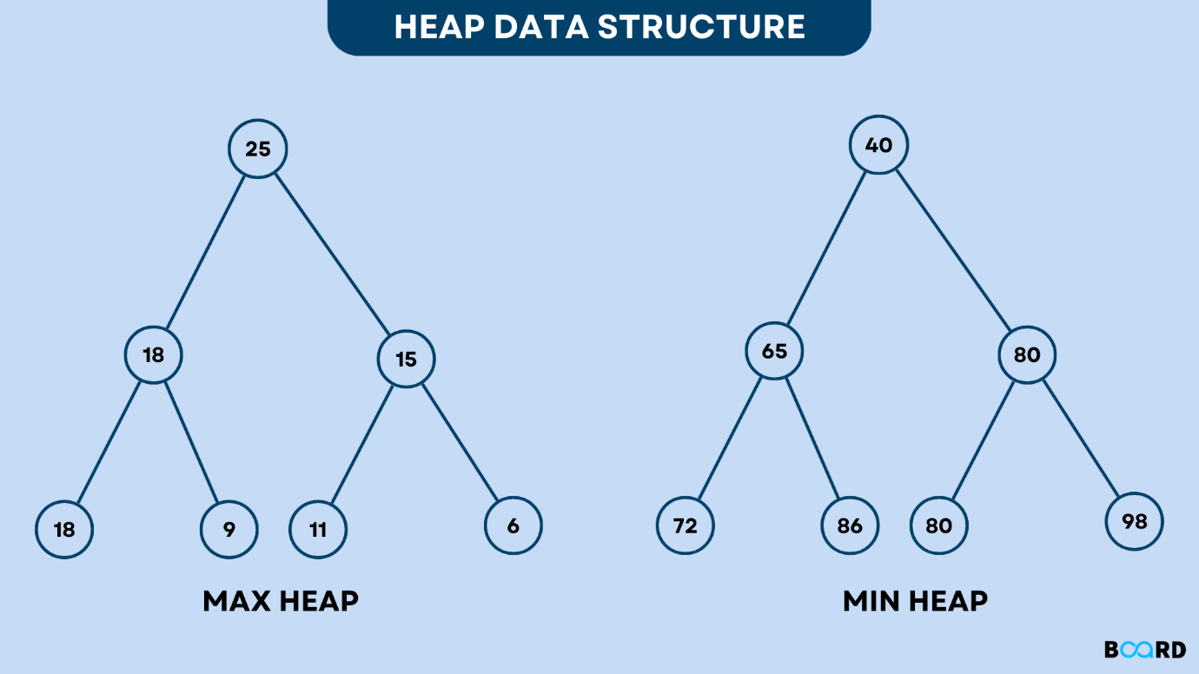

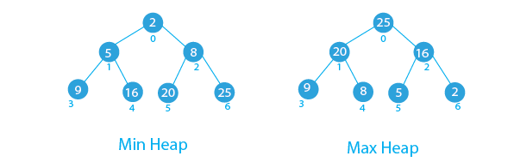

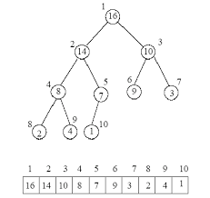
9. HashMap

🔹 Basic Introduction
A HashMap is a hash-based data structure used to store data in the form of key–value pairs. It uses a hash function to convert the key into an index, which helps in storing and retrieving values very quickly.

🔹 Key Points
- Stores data as key : value
- Keys must be unique
- Allows one null key and multiple null values
- Average time complexity: O(1) for insert, delete, search
- Does not maintain order
- Uses hashing internally

🔹 Example
HashMap<Integer, String> map = new HashMap<>();
map.put(1, "Apple");
map.put(2, "Banana");
System.out.println(map.get(1)); // Output: Apple

🔹 Diagram

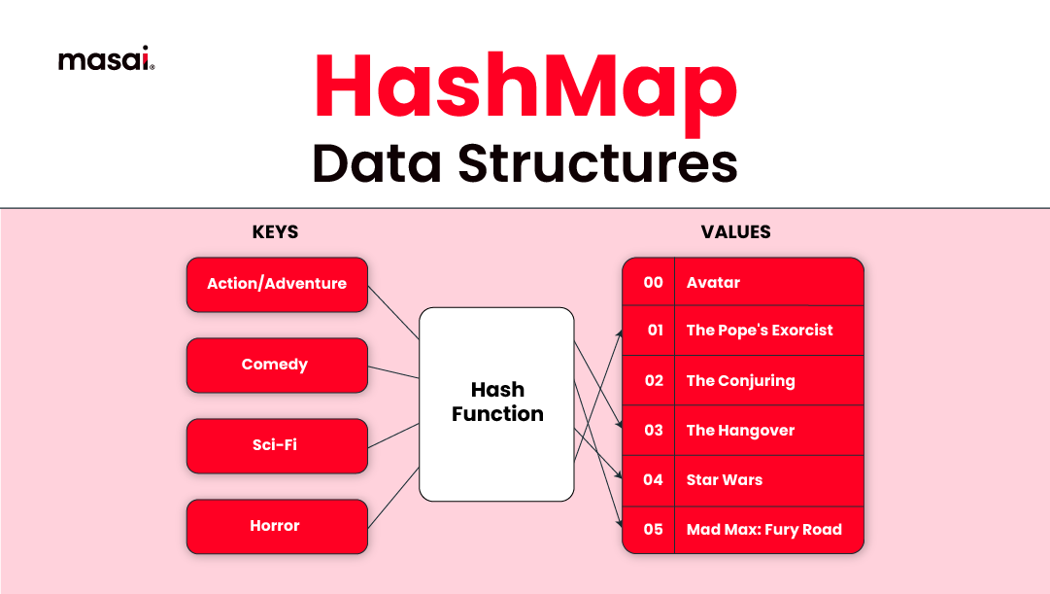
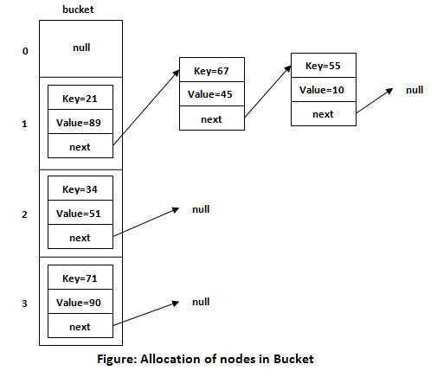

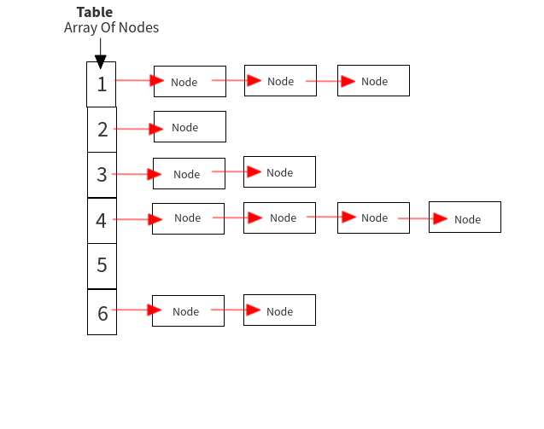

🔹 Real-Life Use Case
- User ID → User details mapping
- Phone directory (name → number)
- Caching data in applications
- Configuration settings storage
10. HashSet

🔹 Basic Introduction
A HashSet is a hash-based data structure used to store unique elements only. It does not store values in pairs and does not allow duplicate elements. Internally, it uses hashing to provide fast operations.

🔹 Key Points
- Stores only unique values
- No duplicate elements allowed
- Allows one null value
- Average time complexity: O(1)
- Does not maintain order
- Internally uses a HashMap

🔹 Example
HashSet<String> set = new HashSet<>();
set.add("Red");
set.add("Blue");
set.add("Red"); // Duplicate ignored
System.out.println(set);

🔹 Diagram
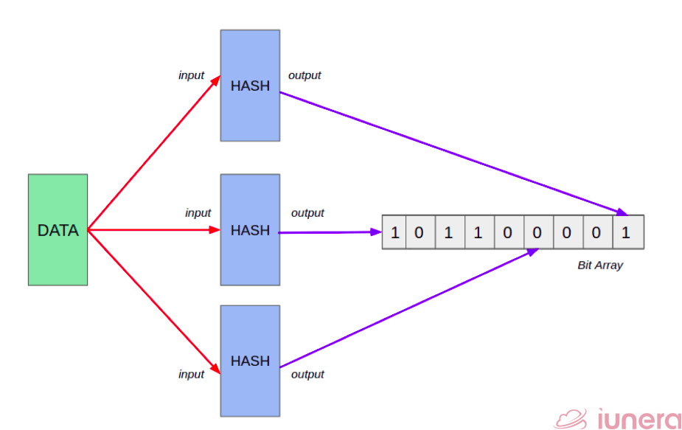
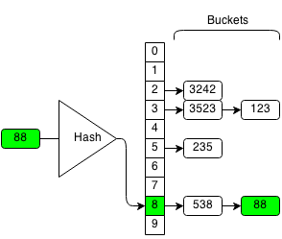
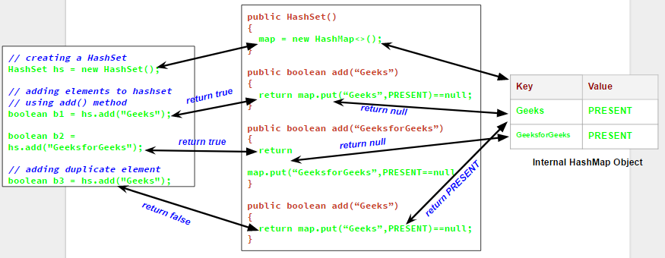

🔹 Real-Life Use Case
- Removing duplicate values from a list
- Tracking unique users
- Checking existence of an element quickly
- Set operations like union and intersection
Both HashMap and HashSet are essential in DSA for fast data storage and retrieval using hashing.

# problem solving techniques in DSA

  - Recursion

🔹 Basic Introduction
Recursion is a programming technique where a function calls itself to solve a problem. Instead of solving the whole problem at once, recursion breaks it into smaller subproblems of the same type. A recursive solution continues until it reaches a condition where it can stop, called the base case.

🔹 Key Points
- A function calls itself
- Must have a base case to stop execution
- Solves problems by breaking them into smaller parts
- Uses the call stack internally
- Can make code short and clean
- Too much recursion can cause stack overflow

🔹 Example
int factorial(int n) {
if (n == 0) return 1; // Base case
return n * factorial(n - 1); // Recursive call
}
This function calculates the factorial of a number using recursion.

🔹 Real-Life Use Case
- Folder and file traversal in a system
- Factorial and Fibonacci problems
- Tree and graph traversal (DFS)
- Divide and conquer algorithms (merge sort, quick sort)
Recursion is an important concept in DSA because many complex problems become easier to solve when they are broken down into smaller, similar problems.

🔹 Diagram
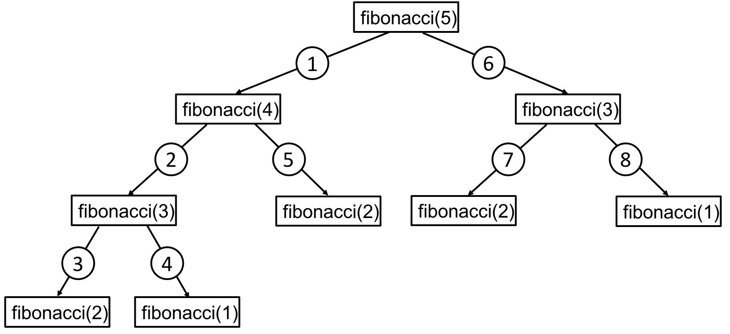

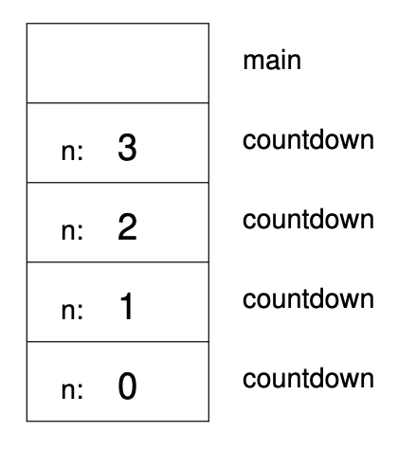
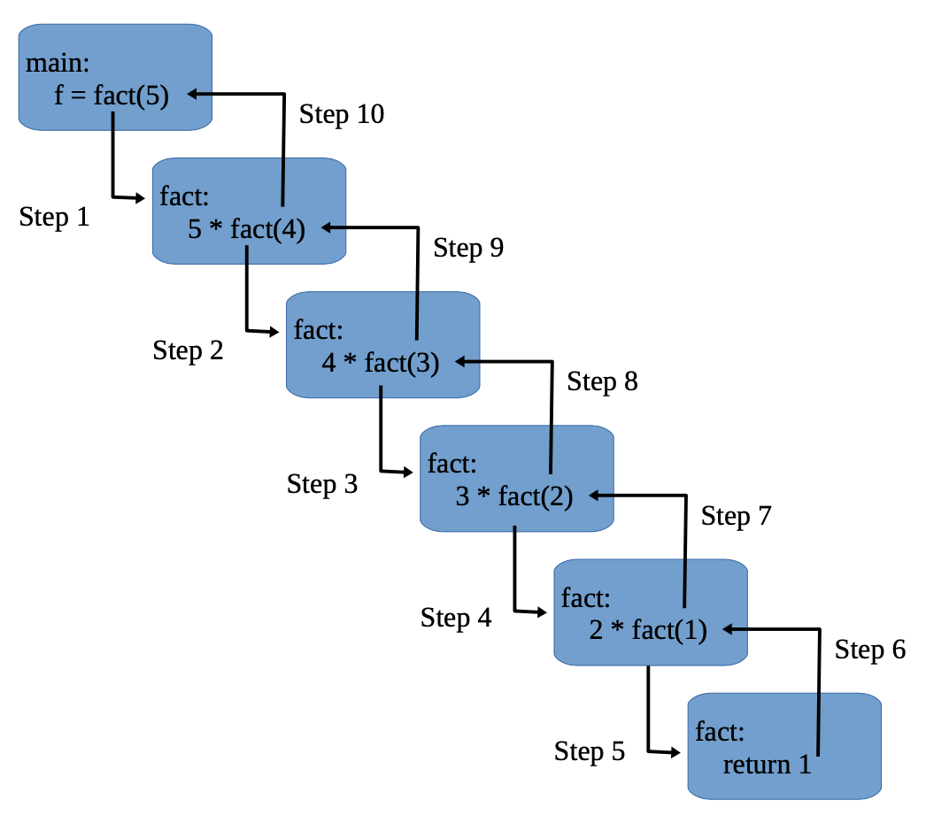

2.Greedy

